Notes of the CALMAC Public Workshop
on the Master Evaluation Contractor Team (MECT) Project
September 18, 2002

Pacific Energy Center
San Francisco, California

Attendance
Name | Company
Ahmed, A. Y. | Occidental Analytical Group
Baker, Michael | SBW Consulting, Inc.
Besa, Athena | SDG&E
Caulfield, Tim | Equipoise Consulting, Inc.
Cavalli, John | Quantum Consulting, Inc.
Cohen, Sam | Energy Solutions
Fields, Alan | RER
Friedman, Rafael | PG&E
Fry, Terry | Nexant
George, Barbara | Women's Energy Matters
Hamilton, Tom | CHEERS
Holding, Eva | The Holding Group
Kelsey, Jim | K W Engineering
Lake, Martha | Alliance to Save Energy Green Schools
Mahone, Douglas | HMG
Mast, Bruce | Frontier Assoc.
McCormick, Michael | Gruenich Research Advocates
McElroy, Kathleen | Xenergy
Pierce, Sam | RLW Analytics
Ridge, Richard | Ridge & Associates
Rubin, Rob | SDG&E
Shirilau, Mark, Dr. | Aloha Systems
Sisson, Phil | Sisson & Associates
Sutter, Mary | Equipoise Consulting, Inc.
Vine, Ed | Lawrence Berkeley Natnl. Laboratory

The notes reflect comments from presenters and workshop participants on the project. Each slide from the formal presentation made by the MECT is shown, along with comments and discussion.

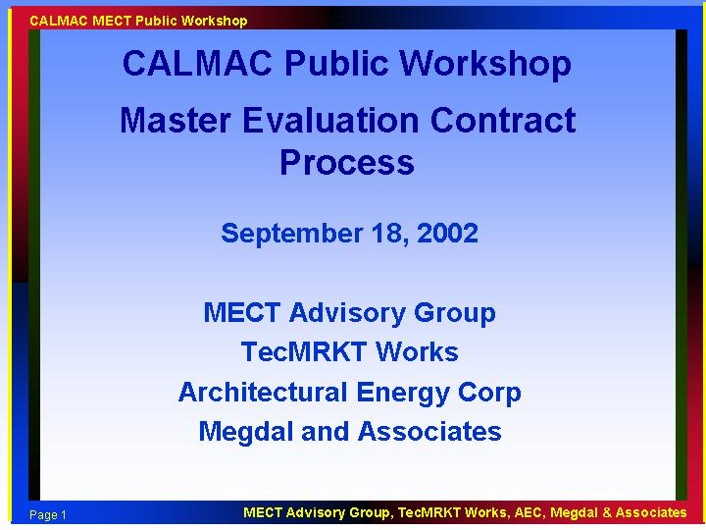

Opening comments were made by Marian Brown, chairperson of CALMAC. The purpose of the workshop is to introduce the Master Evaluation Contract Team (MECT) project and to solicit input from local program implementers and evaluators on the project. The project came from CPUC direction to issue an RFP to hire a team of consultants for evaluation “coordination, consolidation and support.” As of yesterday, the administrative law judge (ALJ) has approved the selection of TecMRKT Works as the contractor for the project. The SCE project manager indicated that contract is now in effect and the project is starting. Eli Kollman from CPUC is here to answer CPUC questions.

Representing the MECT are Nick Hall, TecMRKT Works (prime contractor), Pete Jacobs, Architectural Energy Corporation (subcontractor), and Lori Megdal, Megdal & Associates (subcontractor).

Marian mentioned the September 13, 2002, email solicitation from the CPUC for evaluation firms to submit qualifications by October 15. Attendees indicated that they had received the email and that they were familiar with the process.

Nick Hall did an informal poll of attendees, to assess how many were implementers and how many were evaluators. The room had more evaluators than implementers, but there was some overlap.

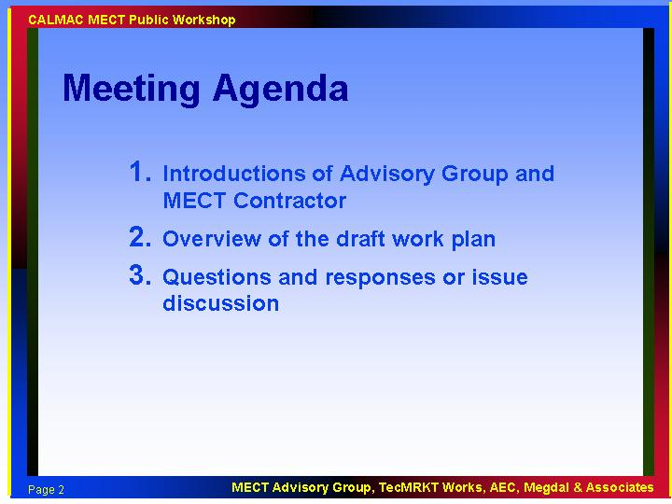

The meeting agenda was presented. Nick asked attendees to hold questions to the end of the presentation if possible, though immediate questions would be addressed.

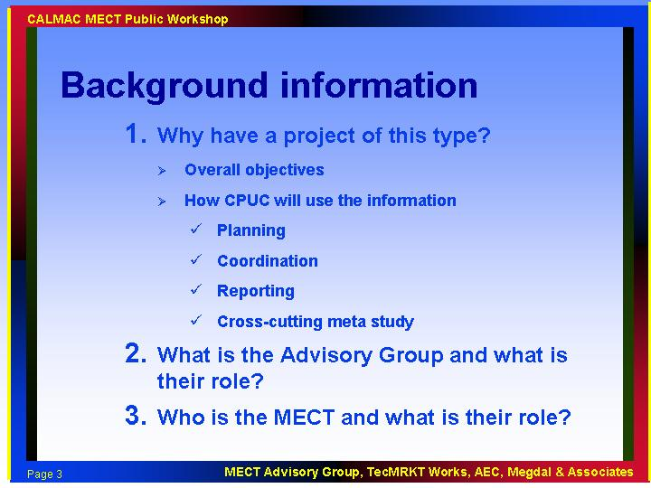

Eli Kollman, of the CPUC presented some background information.

This public workshop is part of the overall MEC project. The CPUC’s overall goals for this project are to achieve coordination and possible consolidation of evaluation efforts. The CPUC at a minimum needs to have some uniformity across local programs evaluation efforts. The first steps in the project involve coordination of evaluation planning efforts. Subsequent steps include review of the evaluations and a meta evaluation. The CPUC mandated the utilities to manage this project under CPUC direction. SCE is the project manager, and theproject advisory groupconsists of a representative from each of the utilities (SCE, PG&E, Sempra) and the CPUC’s Energy Division. The CPUC will have the ultimate decision-making authority on all recommendations made by the MECT.

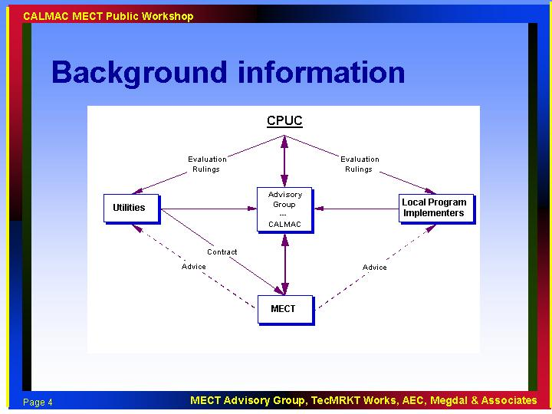

The background slide displayed and discussed an organizational chart, showing the interactions between the various entities in the project. The CPUC is at the top, with ultimate decision-making authority. Program implementers will have opportunities through CALMAC to feed ideas and opinions into the advisory group, while primary contact for the flow of program and evaluation information and evaluation recommendations will be with the MECT.
Discussion items:

- Role of CALMAC. The advisory group is a subset of CALMAC. CALMAC is the vehicle for holding public meetings; CALMAC can direct questions to the advisory group or CPUC.

- Role of MECT (includes the Advisory Group). MECT will make recommendations to the CPUC, and the CPUC will issue a ruling. MECT will have a relationship with implementers, no policing, just coordination. Advice will flow through the Advisory Group to the Commission to the implementers. Conversations between MECT and program implementers will not be directive or demanding in nature. The relationship between the MECT and program implementers is essentially a peer relationship.

- Will MECT conversations be with implementers or evaluators? Mostly with evaluators, but may include implementers to ask about how the programs work.

- Marian Brown: We understand that the evaluators have not been picked yet, but implementers may refer us to an evaluation firm to clarify the intent of the evaluation plans.

- When will evaluators be approved by CPUC? Eli Kollman: I can’t disclose anything but what was in the ruling regarding this process and timing at this time.

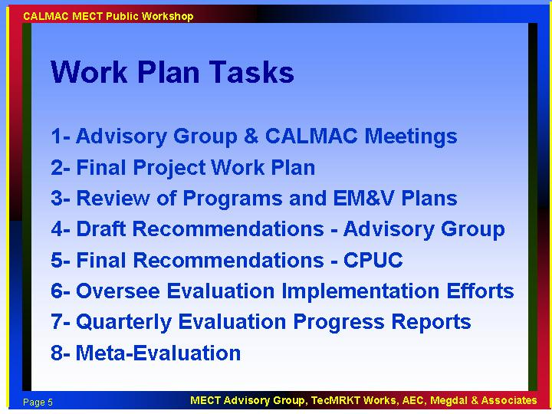

The RFP outlined these 8 tasks: Task 3 contains an early review of programs and plans to expedite the coordination and consolidation recommendations. Task 6 addresses overseeing the evaluation efforts of the individual programs. This is envisioned as a peer relationship, we are not policing the evaluation contractors. We will be developing standard metrics and reporting formats that we expect people to use, to achieve consistency between various efforts.

Discussion items:

- EM&V contractor selection. The programs will need to delay EM&V contractor selection and development of evaluation plans while the early review and coordination/consolidation recommendations are developed. Contract requirements will specify the timeframe for submittal of final evaluation plans. Currently, the PUC has stipulated a 30-60 day contract requirement after evaluators are selected for submission of EM&V plans.

- Collection of baseline data. Implementers are on the street, can collect evaluation data and seek advice from the MECT under their program funding. Implementers can call MECT for advice.

Timing: The MECT requires at least 60 days to complete the first 4 tasks. Draft recommendations will be issued to the advisory group at that time.

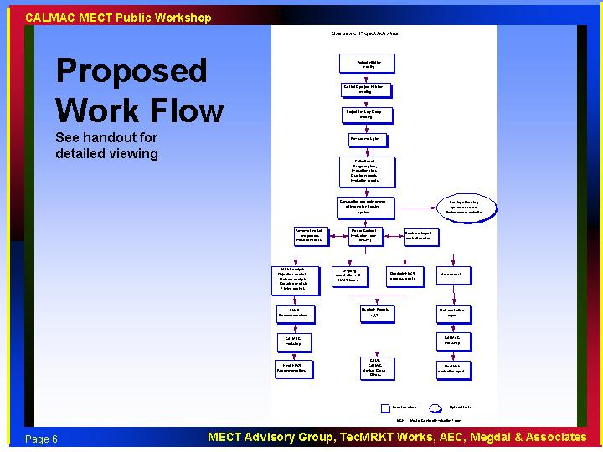

The MECT displayed a diagram that shows the proposed work flow.

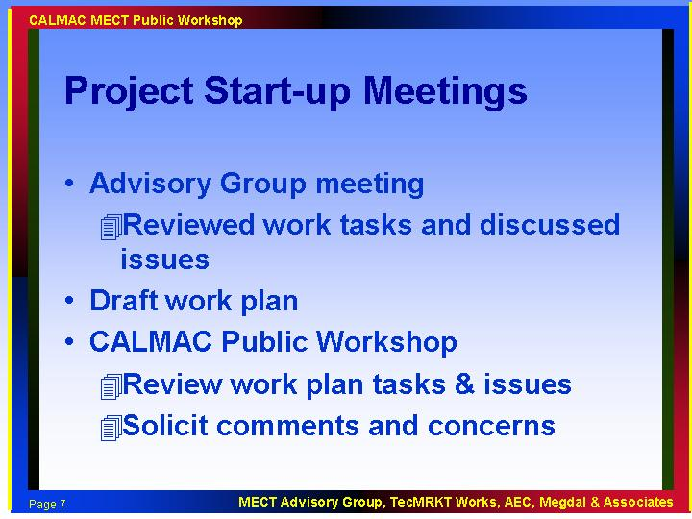

We are now at the CALMAC public workshop step.

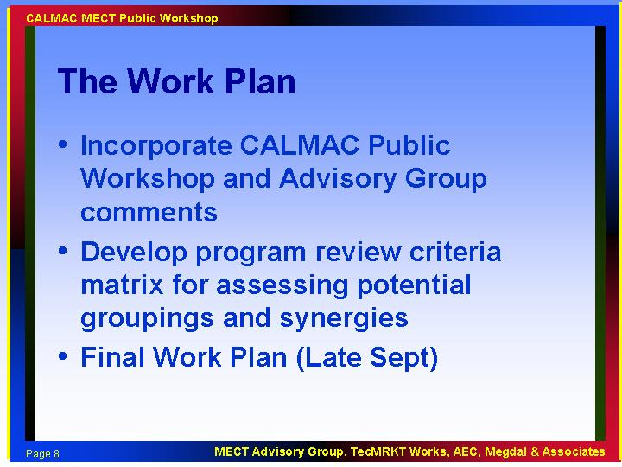

The draft work plan is in the development process.

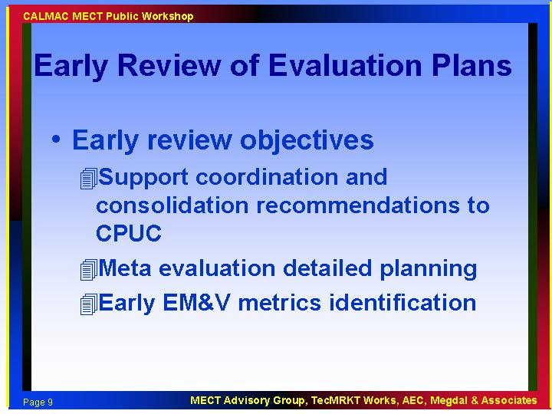

The MECT will review current and near-term future documents to develop coordination and consolidation recommendations.

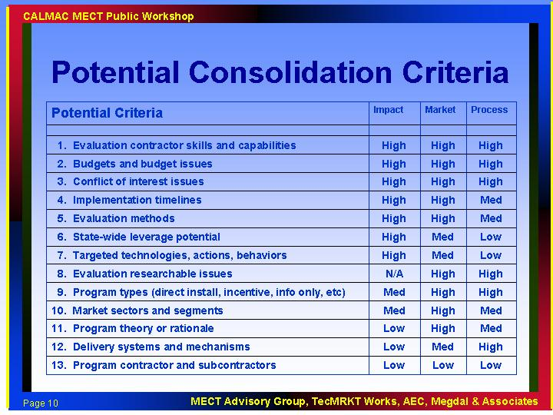

Discussion items:

- What do we mean by consolidation? For example, the evaluation of 7 residential direct install programs might be grouped into one evaluation plan, and the implementers might select 1 or 2 evaluation contractors to carry out the evaluation. No one is yet approved by the CPUC to do evaluations and we expect selection of contractors to wait for our recommendations. Timing is at least 60 days out (under the draft plan being discussed).

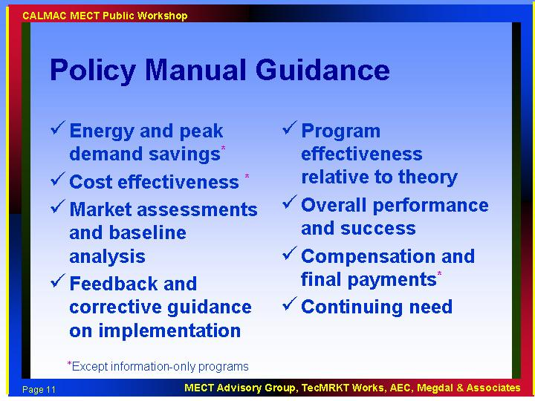

The policy manual lists 8 evaluation goals. These will be prioritized by the MECT for the mix of local programs. Each program (except information-only programs) must report kWh, kW and therm impacts; MECT will recommend other metrics as appropriate.

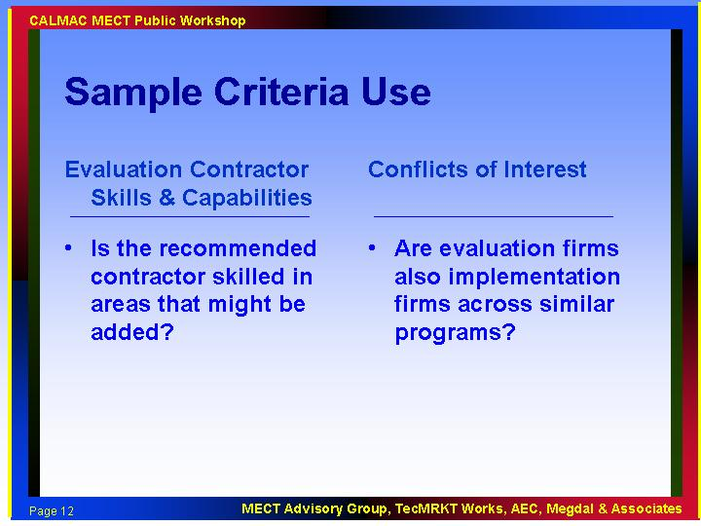

Several examples were provided to clarify the application of the consolidation criteria.

Discussion items:

- Contractor skills – The MECT will recommend skills, not individual firms.

- Marian Brown: some implementers are not familiar with evaluation, and may have recommended an evaluation firm that doesn’t have all the skills necessary to conduct the evaluation according to the evaluation plan. For example, the firm might be good at engineering, but not good at evaluating market effects.

- Implementers can decide who to work with; is it a conflict? The implementers might be more strict, given their interest in the program results. CPUC wants objective info from whoever conducts the evaluation. Implementers don’t have the ultimate choice of evaluation contractor, since these are CPUC-mandated evaluations.

- Marian: MECT influence on the implementers: MECT will make recommendations, but the CPUC will make consolidation decisions. The MECT can interact directly on a limited basis to assist implementers and evaluators with their evaluation plans and efforts..

- Why is consolidation necessary? CPUC: Because it is inefficient to conduct separate evaluations for each program; The programs don’t have enough money to meet evaluation objectives.

- Local contracts are signed and in place with a budget. We don’t want to do anything that will require a change in the contracts.

- Anyone wanting to have their efforts consolidated, talk to MECT; some programs may be counting on it.

- Ed Vine: Two evaluations might be better than one.

- Timing issue was discussed. Local utility programs and statewide efforts are complete in Dec. 2002 while non-utility local programs end in Dec. 2003. This may pose a conflict in timeline for consolidation.

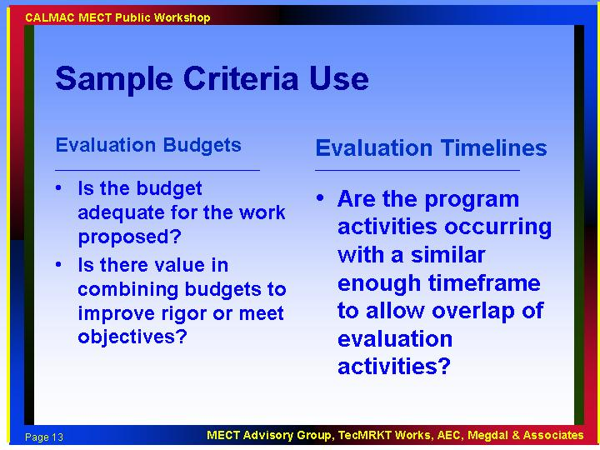

- No comments.

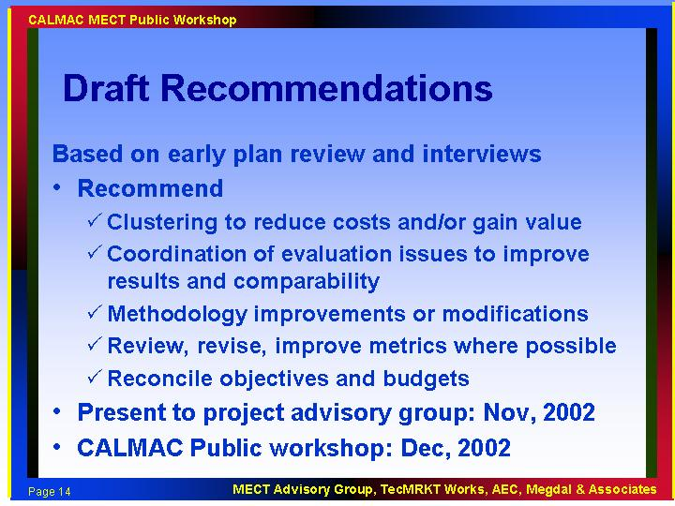

Draft recommendations will take about 60 days to develop. The draft starts a process of review within the advisory group. Estimated 90 days until recommendation are sent to the CPUC.

Discussion items:

- Reconciled budgets may attract more interest from contractors. New set of contractors may enter or leave.

- Will there be a third opportunity for contractors to express interest? CPUC will need to consider the question.

- CPUC can’t compel evaluation contractors to do any work; no obligation implied by submitting qualifications

- Eli Kollman: CPUC may add money if available; no additional resources are available at this time. Contracts are an issue. Equity is an issue that was discussed in general and mentioned again by Eli. We don’t want to reward those with inadequate evaluation budgets.

- Marian Brown: Under-funded efforts may be recommended to be reduced in scope or combined as part of the consolidation effort, as we are unaware of a source of additional funds.

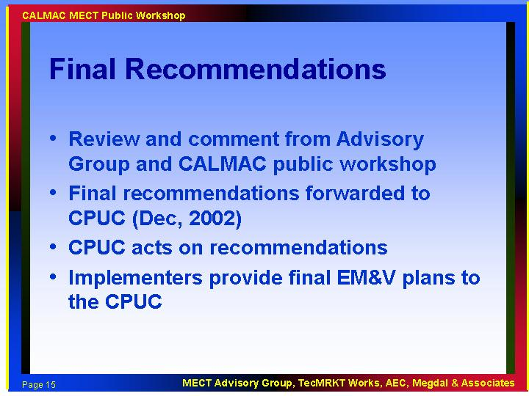

- No comments.

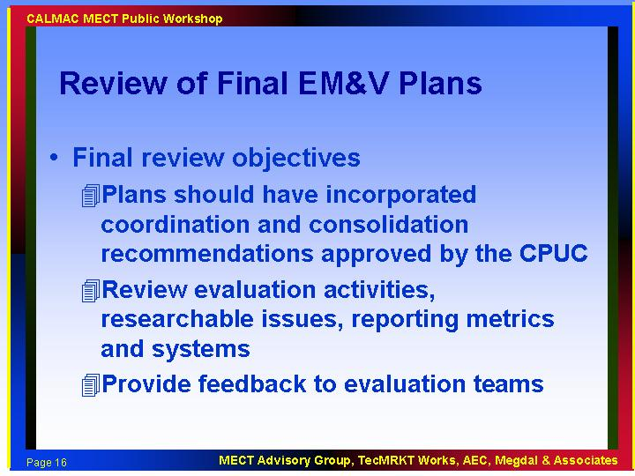

Final plans considering CPUC coordination and consolidation decisions will likely be filed in January. MECT will provide peer feedback/consultations with local teams. CPUC will issue an order for grouping and provide a list. Groups will need to coordinate among themselves to hire a single contractor.

Discussion items:

- Planning starts when list is released – need to file plans within 30 days; however this may not be enough time. If suggested consolidation, then multiple implementers must decide who leads, how contracts are done, which EM&V contractor will be selected, and contracting with them. Teams may not be under contract until March. Then the EM&V plan needs to be developed. Rob Rubin led some of the concern on this issue.

- Recommendations by the MECT can not be based on final plans; this is a concern.

- Utility programs need to be done by the end of 2002 (statewide and local). Programs may be over before evaluator is selected in the current plan of activities.

- Will ALJ need to approve final EM&V plans? Will this put evaluators at risk? Eli Kollman: no, evaluation plan is attached to the contract until the contractor is approved.

- Timing issue; Programs will be underway for a number of months, won’t be able to get corrective feedback in time to improve the program. Marian Brown: Evaluation is in the form of a final report; this is a reality of the world we live in. But, on-going coordination and feedback can occur to provide feedback as it is available from the evaluation efforts.

- Doug Mahone; The best solution is to put the evaluation money into a big pool, but money is tied up in local contracts and is already hardwired. The CPUC should pull the evaluation money out of the local contracts. Marian Brown: not an option for this round.

- Eli Kollman: consolidation is a small part of the MECT and the related CPUC effort, more emphasis on evaluation coordination and on the meta evaluation.

- Program proposal scoring criteria did not address EM&V; programs with small EM&V budgets may have scored better overall because they can get more done per dollar.

- John Cavalli: Feedback is more important than anything else; other problems can’t be fixed. Get EM&V contractors underway ASAP, do not wait 60 days.

- Will contracts be issued from implementers? This may be a problem for local governments, which must use a competitive process. List of qualified contractors allows for a competitive procurement process.

- One proposal was to only consider for consolidation those with inadequate EM&V funding.

- There was a request to provide implementers with a list of information they need to get from their EM&V contractors.

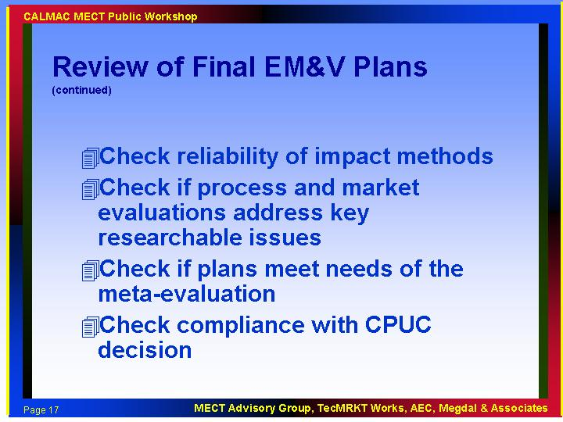

Discussion items:

- How does implementer know what the quarterly report needs are? They were not budgeted for. Marian Brown: These requirements will not be onerous; just part of normal evaluation reporting.

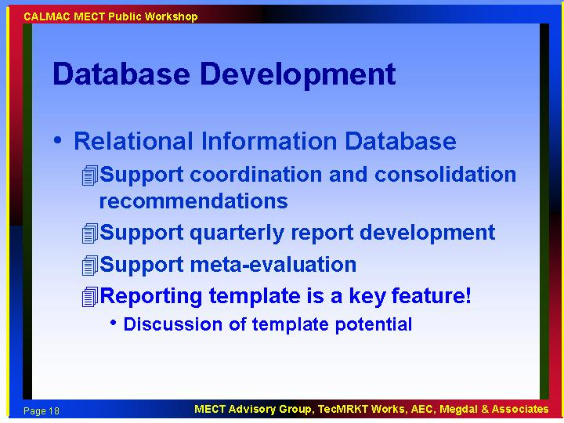

Discussion items:

- Ed Vine: Attribution of market effects and energy savings to individual programs will be hard, since there are so many programs and lots of noise in the market.

- Meta analysis. The focus will be mostly on program impacts, not evaluating the evaluations. Marian Brown: The meta evaluation will address both issues.

- Plan is for the database to be an internal resource; optionally it could be made available to the public.

- Marian Brown: EM&V requirements for quarterly reporting will not be onerous

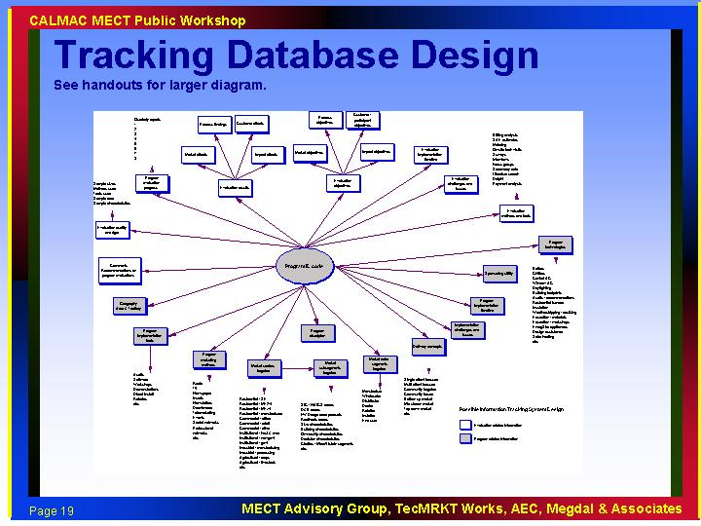

- No comments.

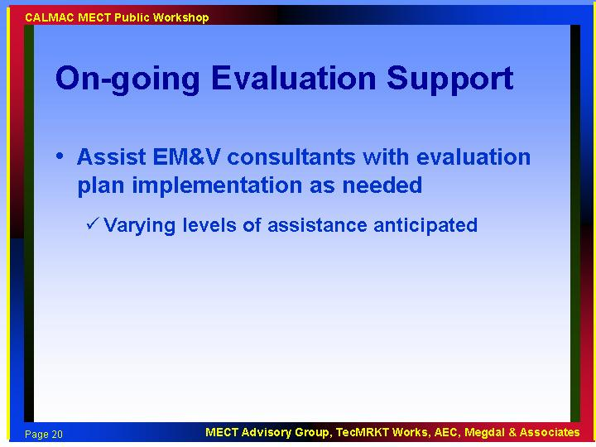

- No comments.

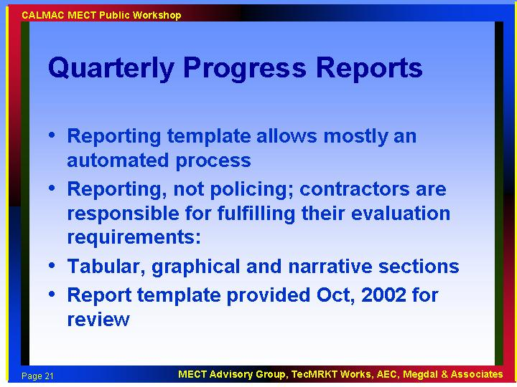

- No comments.

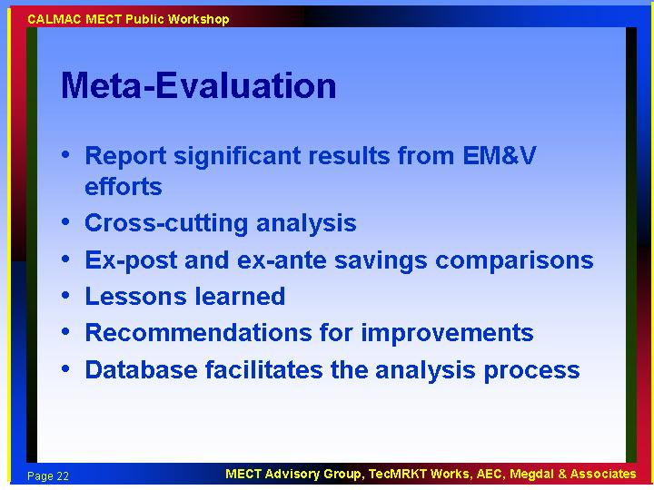

The meta evaluation will focus on cross-cutting evaluation process issues.

Discussion items:

- Will the Office of Ratepayer Advocates (ORA) be involved in review of final evaluation reports and results? Eli Kollman: CPUC Energy Division will review the results.

- Lori Megdal: We (MECT) will not be reviewing each result per se, but what can we learn across programs.

- Ed Vine: ORA will continue to do what they have been doing.

- Nick Hall: We will be involved in evaluation process results reviews; not adjustment of results.

- Doug Mahone: Will we be doing cost effectiveness calcs based on ex ante savings? Eli Kollman: spreadsheets already calculate ex ante cost effectiveness.

- What will happen when results are in? Individual EM&V reports are basis of final payment, not meta evaluation results. The MECT will also make recommendations for changes to the EM&V process as appropriate. .

- Mike Baker: Consolidated evaluations need to provide program-specific results for final payments. Consolidation for sampling is a lost cause.

- Many EM&V budgets are based on counting and verifying measure counts, not much process and market evaluation planned. Some programs put the full CPUC-required evaluation goals from the policy manual into their proposals, but only budgeted verification. Some discussion on different interpretations of CPUC rulings and Policy Manual, whether verification is all that is required or whether the list in the Policy Manual is expected,. How does that mesh with CPUC-approved contracts, some that have only verification and others that include language listing the full set of goals but inadequate budget to perform these?

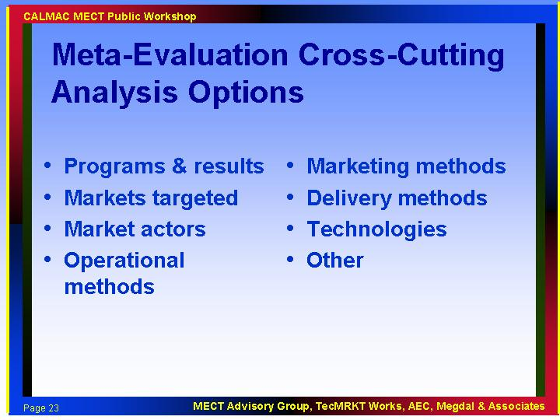

- No comments.

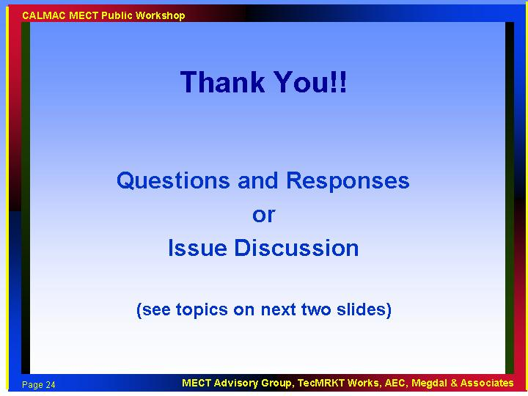

The formal presentation was followed by an issue discussion.

Valerie Richardson: Can we develop a list of topics to guide the discussion?

The CALMAC Workshop breaks for lunch. A pro-forma list of discussion topics is generated by the MECT.

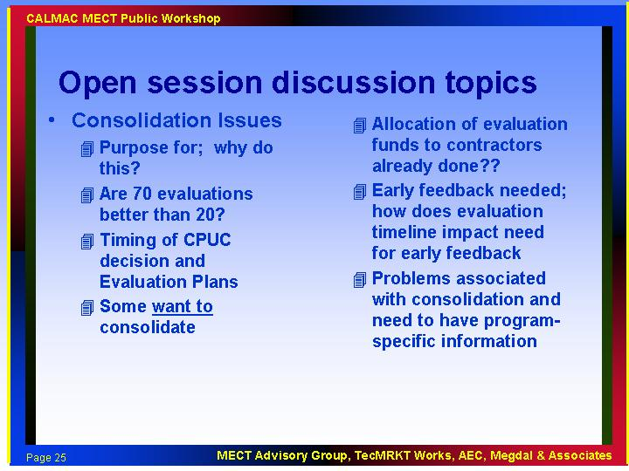

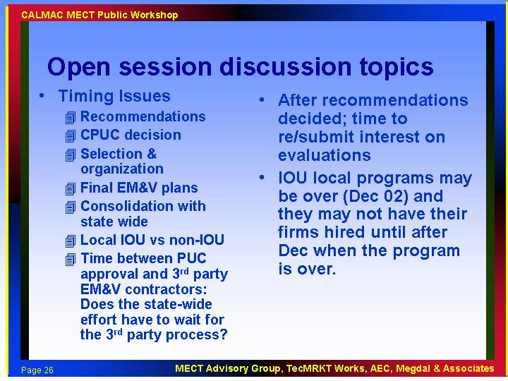

Workshop participants return from lunch. Tom Conlon is back on the phone.

Comments and Discussion Items:

- Timing for municipalities to issue RFPs for EM&V contractors – could take months because of their processes.

- Implementers might want to get together to discuss consolidation interests. Could we squeeze in an interim consolidation workshop?

- Schools programs may want their evaluations to be consolidated.

- PG&E consolidation interests include school programs and the Pacific Energy Center.

- Mike Baker – Like to see consolidation off the table or let the 90-95% go and identify quickly those few where opportunities are substantial/necessary. Later comment, may want to redefine consolidation based on evaluation methodology, not putting teams together with other criteria. That is, cooperate in designing and implementing phone surveys across programs etc.

- Program designs need to be very similar; budgets need to be similar for consolidation to work. Eli – This is also a definition issue; the CPUC expects similar analysis regardless of contractor.

- Consider priorities when planning the project– coordination and meta evaluation should have a higher priority; consolidation planning will have a major cost on the implementers and may not result in much actual consolidation. Don’t hold up process for 90 days if we are only going to consolidate a few programs

- What percentage of programs are likely to be consolidated?? Not much economy apparent in program designs.

- John Cavalli: Suggest CPUC put out approved list in next 2 weeks. Then let implementer decide to go ahead and contract or whether to wait for the consolidation recommendations.

- EM&V firms are already looking for consolidation opportunities. If you manipulate the process, you may destroy innovation.

- Implementers already know which evaluation firms they want to use. Put out a list of preferred contractors based on implementer recommendations soon. Add names to get new faces for people who don’t have a clear choice.

- Have MECT conduct evaluation plan review in next few weeks. Ask implementers if they want consolidation; ID those who obviously need help. Give feedback directly to implementers who will consider the recommendations in a bottom-up rather than top-down process.

- Will recommendations state that some programs will need process, market studies if none were planned? CPUC may say, we can’t approve your plan until you get a market evaluation.

- Mike Baker: Consolidation is the only piece that is in the critical path. Put this on a separate track, so it can be done more quickly. Get this resolved ASAP.

- One of the prior CPUC orders says that the emphasis should be on measure count verification. Some firms planned no evaluation budget for education programs at all. Eli Kollman: CPUC intent is to get beyond just widget counting.

- Get the measure counting activities going first; fund evaluations to address other questions later.

- Rulings that come out of the MECT process should not affect contract terms – it was tough to get contracts figured out already

- Put the consolidation effort on a two track process – quick decisions for “no brainers,” more time for harder decisions.

- Eli Kollman: think about timing of statewide program evaluation RFPs, and impact on this process.

- Please distribute a copy of discussion slides

- Do IOU local programs need to wait for recommendations, due to timing? These programs end in December, 2002, this may be before recommendations are approved.

- Program Budgets Comments– impact of EM&V costs on overall program cost effectiveness, negative incentive for providing comprehensive evaluation. Don’t reward contractors that under-budgeted the evaluation effort. Cost for reporting requirements not planned. Marian Brown: Reporting requirements will not be onerous – let’s take this issue off the table.

- Consolidation and evaluation budgets are tied – responsibility should be with the implementers to make consolidation decisions. They are ultimately responsible for proving their programs are effective. May not get final payment or get continued funding if they underestimate budgets.

- Program implementers will collect a lot of the basic measure count data; who is ultimately responsible for the quality of the data?

- Speed up meta evaluation schedule; current schedule won’t provide feedback to affect program design decisions for the next round of programs.

- Ed Vine: Small implementers don’t understand the value of evaluation – they think it’s just a hoop they need to jump through. Put a stipulated evaluation set-aside in all contracts; have the program implementers focus on program innovation and let the evaluation contractors figure out how to spend the evaluation money.
Appendix.

List of attendees (in person)

Name | Company | Phone # | Email Address
Ahmed, A. Y. | Occidental Analytical Group |  | aahmed02@earthlink.net
Baker, Michael | SBW Consulting, Inc. |  | mbaker@sbwconsulting.com
Besa, Athena | SDG&E | 858-654-1257 | abesa@semprautilities.com
Caulfield, Tim | Equipoise Consulting, Inc. |  | equipoise@covad.net
Cavalli, John | Quantum Consulting, Inc. | 510-540-7200 | Jcavalli@qcworld.com
Cohen, Sam | Energy Solutions | 510-482-8386 | sam@energy-solution.com
Fields, Alan | RER | 858-481-0081 ext. 429 | alan@rer.com
Friedman, Rafael | PG&E |  | rafi@pge.com
Fry, Terry | Nexant |  | tmfry@nexant.com
George, Barbara | Women's Energy Matters | 916-925-7058 | bgwem@igc.org
Hamilton, Tom | CHEERS |  | Thamilton@cheers.org
Holding, Eva | The Holding Group |  | eva@theholdinggroup.com
Kelsey, Jim | K W Engineering |  | kelsey@kw-engineering.com
Lake, Martha | Alliance to Save Energy Green Schools |  | martha.lake@attbi.com
Mahone, Douglas | HMG | 916-962-7001 | dmahone@h-m-g.com
Mast, Bruce | Frontier Assoc. |  | bmast@frontierassoc.com
McCormick, Michael | Gruenich Research Advocates |  | mmcormick@gralegal.com
McElroy, Kathleen | Xenergy |  | kmcelroy@xenergy.com
Pierce, Sam | RLW Analytics |  | sam@rlw.com
Ridge, Richard | Ridge & Associates | 510-865-6011 | rsridge@attbi.com
Rubin, Rob | SDG&E |  | Rrubin@semprautilities.com
Shirilau, Mark, Dr. | Aloha Systems |  | Mark@alohasys.com
Sisson, Phil | Sisson & Associates | 415-845-8820 | philsisson1@attbi.com
Sutter, Mary | Equipoise Consulting, Inc. | 510-864-8507 | msutter@alamedanet.net
Vine, Ed | Lawrence Berkeley Natnl. Laboratory | 510-486-6047 | elvine@lbl.gov

Participants attending via phone connection:

Name | Company | Phone # | Email Address
Conlon, Tom | Geopraxis
Irvine, Linda | PECI
Jensen, Val | ICF Consulting
Lutzenhiser, Loren | Portland State University
Rabl, Veronica | Aspen Systems
Sterrett, Dick | Alternative Energy Systems Consulting (AESC)
Tapawan—Conway, Zenaida | CPUC Energy Division

